**Project 02_04_02**

In this Project we will build two-part PHP form applications to test our knowledge of the unit. Be sure to document all of your code to indicate your understanding.

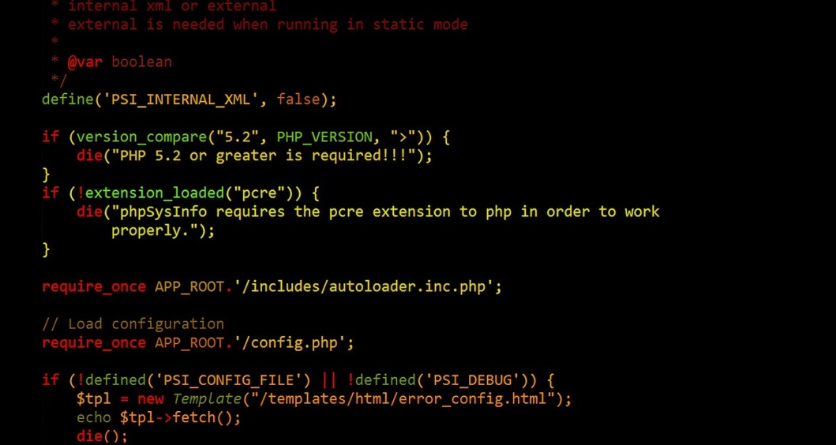 

In this Project, you will create a two-part form that calculates an employee’s weekly gross salary. It will perform this calculation based on the number of hours worked and an hourly wage that the user chooses.

Use an HTML document named ***Paycheck.html*** as a Web form that contains two text boxes. One will take in the number of hours worked, the second one will take in the hourly wage. The form will also need reset and submit buttons. You are expected to provide a form that has a nice appearance, so use some good spacing, and add a little CSS to accomplish that. It will affect the Professionalism and Technique parts of your grade.

Use a PHP document named **Paycheck.php** to receive and process the form submission. Compute any hours over 40 as time and a half. Provide a hyperlink back to the form, if it is successful, to go back and enter more paychecks. Make sure you are doing all necessary validations for required fields, as well as for proper numeric data. Hint: use Google to find suitable Regular Expressions to handle the numeric input. Be sure to provide some professional looking user output, so make sure to format the decimal places that you display.